
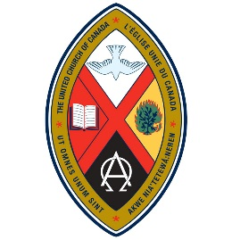
WOMEN OF THE UNITED CHURCH:
CHINOOK WINDS AND NORTHERN SPIRIT
CONFERENCE AND ANNUAL MEETING
“Living Water”
April 10, 3:30 p.m. – April 12, 1:00 p.m., 2025
(Registration at 2:30 p.m.)
FCJ Retreat and Conference Centre
219 – 19th Ave. SW, Calgary, AB
All Women of the Church are Welcome
Please complete the Registration Form and mail with payment to the Registrar by March 7, 2025 if you are staying at the FCJ Centre. Commuters must register by March 31, 2025. Make cheques payable to Women of the United Church (WUC) with Conference/Annual Meeting in the Memo line, or e-transfer to wuctransfers@gmail.com (the account has autodeposit, so no question or answer are required).

Registrar: Margery Wright, 38 Danforth Cres., St. Albert, AB T8N 4W8; phone 780 419 3224; margery.j.wright@gmail.com

Financial Assistance is available. See the attached page for information on the Christensen/Dryburgh Fund.

REGISTRATION FORM
Double room at FCJ: two nights, with all meals, snacks and program: $250/person
Single room: two nights, with all meals, snacks and program: $300
Commuter – not staying at FCJ, all meals, snacks and program (includes breakfasts): $140
(The cost of this event is being subsidized by the WUC and the national UCW.)
Name ____________________________________________________________________________________
Address __________________________________________________________________________________
Telephone __________________________ Email _______________________________________________

Roommate’s Name _________________________________________________________________________

Allergies/Dietary Concerns __________________________________________________________________
Other information or concerns: _________________________________________________________________________________________
_________________________________________________________________________________________
If you have books to share, bring them for our book exchange table!

